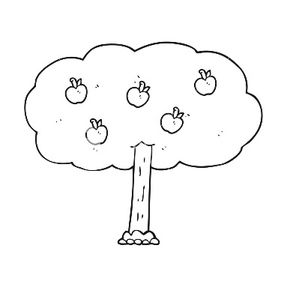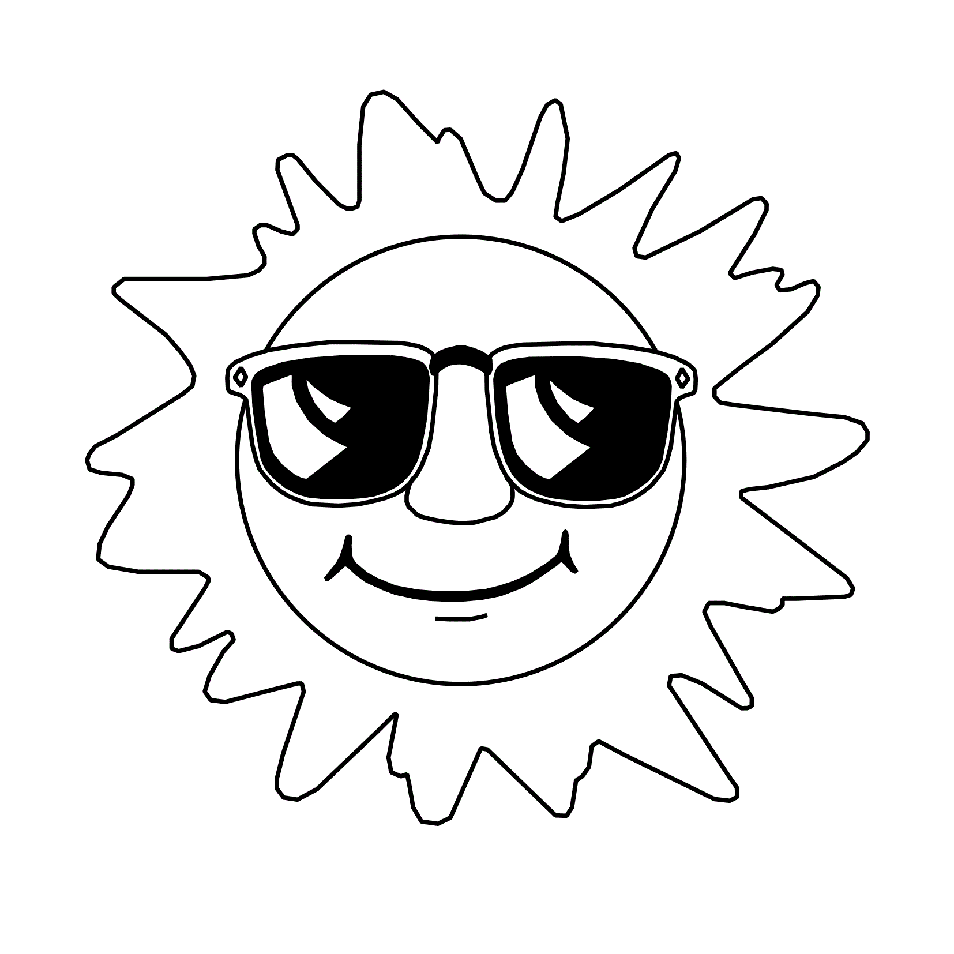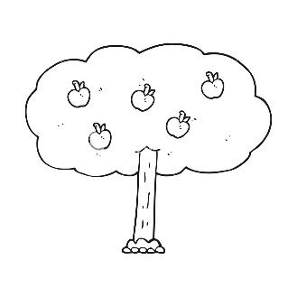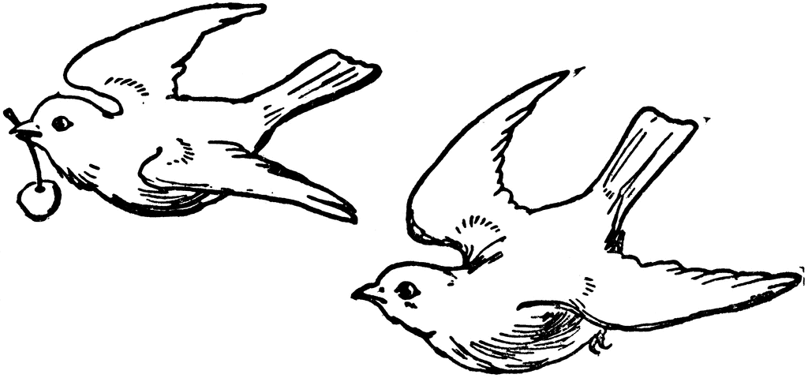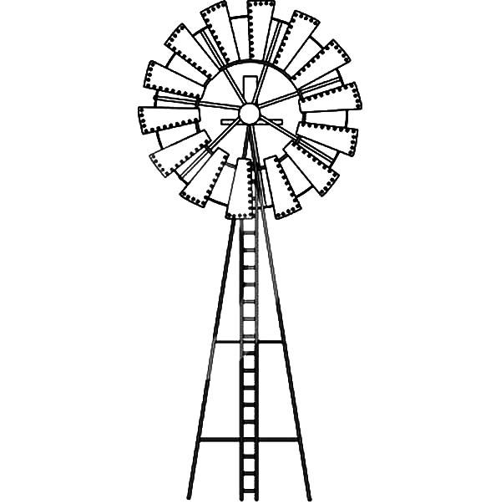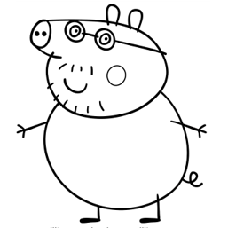Related imageRelated imageRelated imageRelated imageRelated imageRelated imageRelated imageRelated imageRelated imageRelated imageRelated imageRelated imageRelated image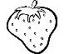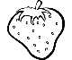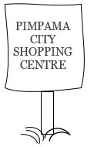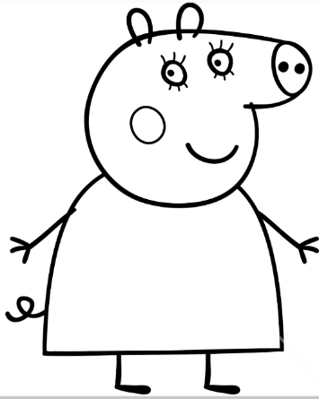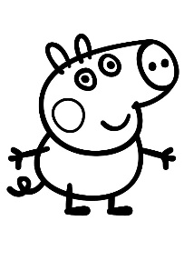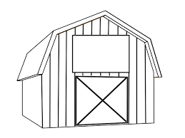

© Vision Precinct Pty Ltd

Name:

Figure 1 Vision Precinct Pty Ltd

**Let’s get our eyes tested Mummy Pig**

**Can we pick some strawberries too Daddy Pig?**

**I think I need to get glasses**

**There’s a new Optometrist in town**

**VISION PRECINCT**